INTRODUCTION :

Whenever IRIS sends a request for activation to ACTIVA, it does so by invoking event ‘wi’. This event corresponds to ‘AC_RECEP_IRIS’ tuxedo service.
As the name of the service indicates, it is the service which is used to receive all kinds of activation requests for GSM, GPRS and all other additional services from IRIS

- AC_RECEP_IRIS:

Main service responsible for receiving the incoming request of activation from IRIS
Any incoming request for activation is termed as a Contract.
The input buffer of the service contains several fields which carry the information about the contract which has to be activated.
The service initially performs certain validations and once these validations are performed the details of the request are stored in ACTIVA tables like x_act_solicitud, x_act_servicios and if the contract contains GPRS information or additional services attached then other active tables are also updated
Once the data has been stored in ACTIVA tables, the status of contract is ‘PA’
i.e. Pending Analysis.
From AC_RECEP_IRIS the service AC_REC_DECISION is called.

2. AC_REC_DECISION:

This service plays the role of a decision maker. It consults the various systems like SCOREX, BADEX,INFORMA and decides whether the contract will be activated or not.
Within AC_REC_DECISION it obtains the request inserted in x_act_solicitud and depending on some flags in it calls the event (7x) for informing BADEX system.
After that it also calls the SCOREX services like SCOR_DEC_CONS for credit score consultation.
Depending on the outcome, the request state is updated to ‘PE’(pending activation) or ‘PS’ (Pendiente Sondeo or Pending Survey) or SU (Suspended) or RC (Rejected)
If the risk query is successful, then the state is changed to ‘PE’ and the event ‘wb’ is invoked which corresponds to the Tuxedo Service AC_ACT_CONTRATO.
This is the tuxedo Service which is responsible to activate the Contract in Clarify and also to update other systems like SERPA,ARBOR, SAP .etc

3. AC_ACT_CONTRATO:

This Service retrieves the information from the active tables and updates the Clarify tables like table_contact, x_cuenta , site_part . If there are supplementary services or promotions attached with the request, then x_site_ss ,x_site_promo are also updated.
After this updation is made into Clarify it calls the events like ‘01’ ,’h2’ , ’q8’ to inform other systems like ARBOR,SERPA and calls some of the tibco services like TIB_C_DatClient and TIB_CCAR_UPD to update other systems too.

4. AC_ALT_SVC& SE_ACT_SVC :

AC_ACT_CONTRATO informs Serpa through the service AC_ALT_SVC.
This service prepares the Serpa order for activation on the network. The service SE_ACT_SVC sends the order to SERPA. Once this MSISDN is activated in network the State of MSISDN changes in site_part table to AC(Active).

ACTIVATION FLOW FROM IRIS:

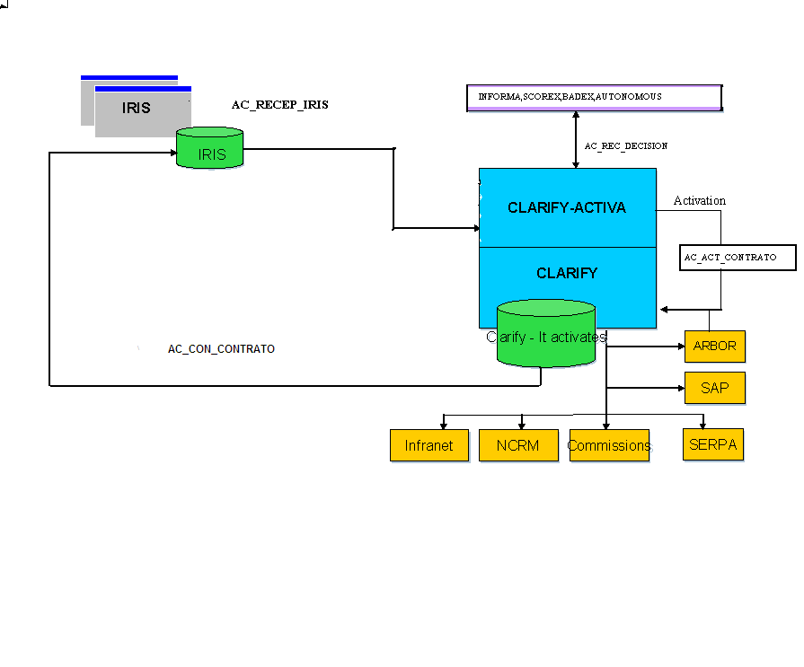

Any kind of activation request can be visible through ACTIVA form (1381.cbs):

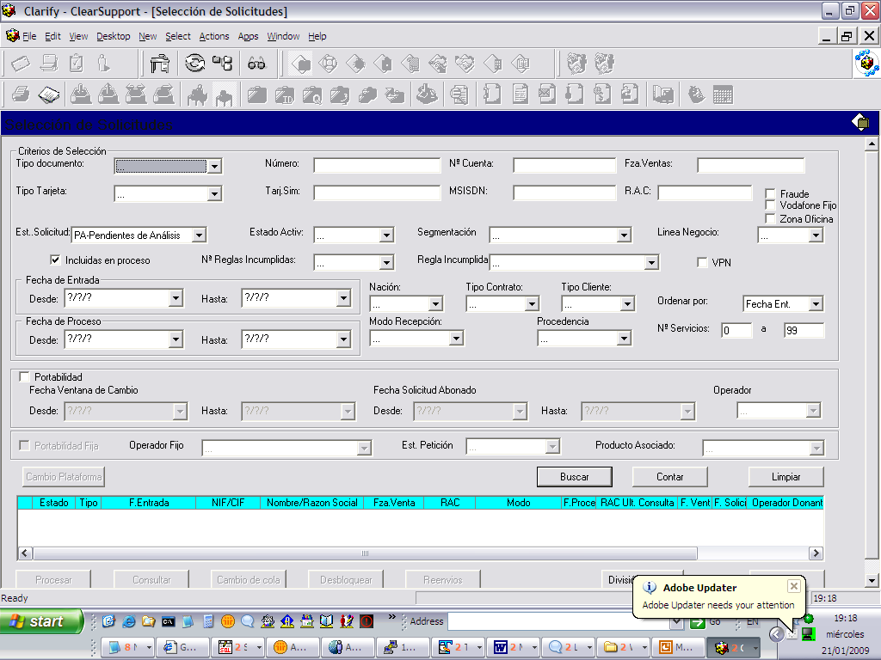

We can select a Selection Criteria by providing the NIF/CIF or (From and To) Dates of Entry of Request or Status of Requests and click on ‘Buscar’ button as shown :

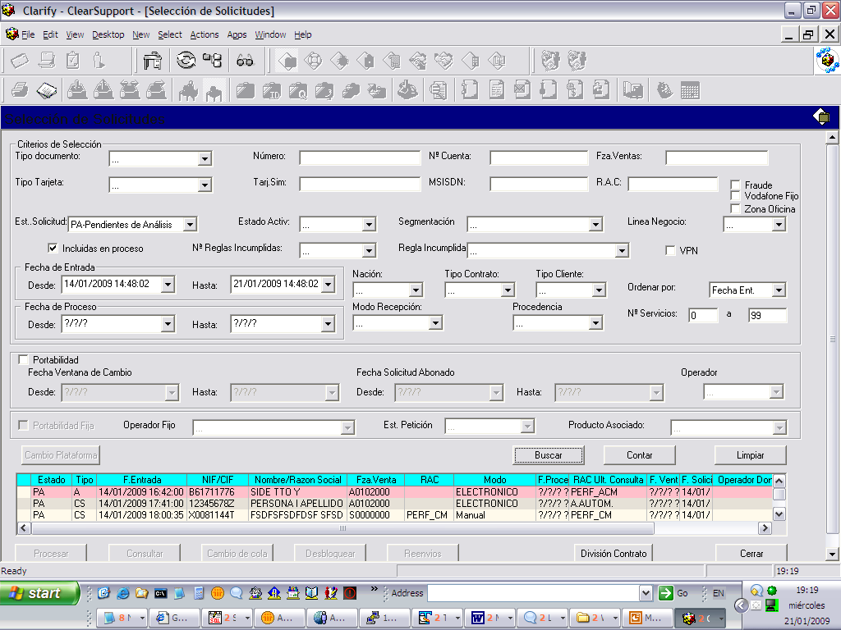

The different states of a request are like :
AC-Activated
PA-Pending Analysis(Documents submitted are under review)
PD-Pending Documents(Documents not yet submitted)
PS-Pending Sound Score (When the result from Scorex is not good)
PE-Pending Activation(not yet Activated)
RE-Redo the Activation Process
SD-Suspended Documentation(When the analysed Documents are not
valid)
SU-Suspended (Rejection of entire Request)
RD-Rejected by Distributor
RC-Rejected

Request which are in ‘PA’ state can be processed further from ACTIVA forms.
When we select a particular request the ’Processar’ button gets enabled , when we click on ‘Processar’; the form that opens up is
“Gestion De Contrato” i.e. for ‘Management Of Contracts’ (1630.cbs)

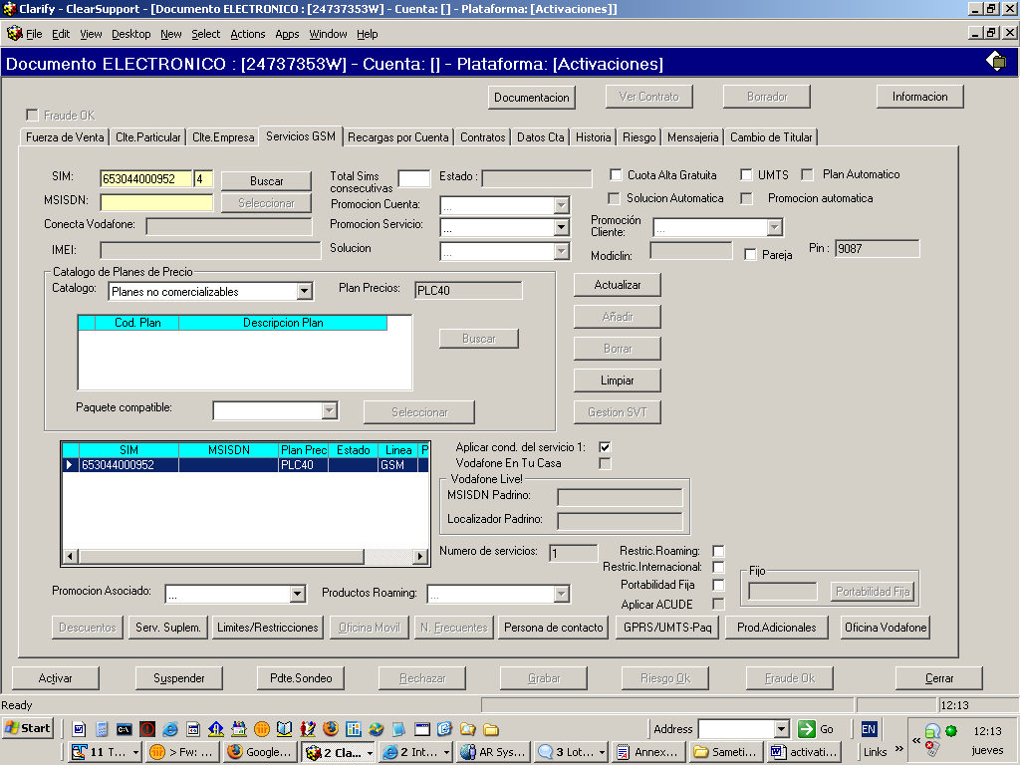

In this particular form if the contract to be activated, has a sim number, plan of price or msisdn attached with it, it appears in the grid, else we need to provide these information before activating the contract.
We select the entry in the grid and inorder to add additional product or supplementary services, GPRS we need to click the buttons ‘Serv Suplem’, ’Prod Adicionales’ ,‘Oficina Vodafone’ etc present at the bottom of the tab form ‘Servicios GSM’

Once we click on ‘Activar’ button the form does some validations and then calls the event ‘wb’ which corresponds to the service ‘AC_ACT_CONTRATO’ which updates the information relating to the contract in Clarify 10.1 and also informs SERPA,ARBOR about it. Once activation is done successfully the status of request changes from PA to PE and we can check state of MSISDN in site_part table of Clarify10.1.

Activation Flow For IN/OUT Portability Of PostPaid Services:

- Incoming Portability for postpaid services

The process of incoming portability for postpaid services has the following steps:

IRIS sends the portability contract to ACTIVA, in order to do that, IRIS calls the Tuxedo service AC_RECEP_IRIS by means of wi event.

After having received the request from IRIS, the Tuxedo service AC_RECEP_IRIS:
Does some validations (checks whether the numbering plan is active in Vodafone, etc.).

Stored the request in the ACTIVA tables (table_x_act_solicitud, table_x_act_servicios, table_x_act_pdtes, …). This request is recorded with PA status (Pendiente de análisis) and the flag of portability equal to 1.
From ACTIVA we can check the status of the request opening the form 1381 (“Selección de solicitudes”).

Tuxedo service AC_REC_DECISION is called.

This service is called from AC_RECEP_IRIS Tuxedo service.
The AC_REC_DECISION gets all the requests in PA status, does some validations over them and check with Scorex the risks regarding them. Depending on the results of these checkings:

If the response of Scorex is an affirmative one:
i. The SActUpdEstado service is called by means of the “jf” event. This service puts the request into “RO” (Risk ok) status and informs to portability Robot.
In order to launch the SActUpdEstado service, we have to push on “Riesgo OK” button.

If the response of Scorex is a negative one:
The request is updated to suspend status and is sent to the RAC (which from ACTIVA window 1630 validates the request and accepts or rejects it manually).
The AC_CON_CONTRATO service is called. This service informs IRIS about the problems during the validations.

Aditionally, AC_REC_DECISION service is called by means of batac_decision process (which is launched periodically and manages the requests that need to be reprocessed).
The batac_decision process gets all the registries in table_x_act_pdtes which timestamp field has not be updated since a specified date (this time is parameterized). For each registry that must be processed the AC_REC_DECISION Tuxedo service is called by means of “wh” event.

Wait until the donor company ‘operadora donante’ approves the request and informs the date for the change (Ventana de cambio).

Once the portability Robot has the date for the change, calls AC_FVC_PORTA Tuxedo service.

:
This service validates the parametrization of the request in ACTIVA tables (Price Plan, Promotion, Solution, etc.);

It is confirmed that in the input buffer contains the date for the change, the new status of the request, and the company that owns the telephone number and comes in this input buffer is the one that appears in the numeration plan.

It is checked whether the request is in the system (in the ACTIVA tables) or not. In the same way, this request is updated in the ACTIVA tables with the values received in the input buffer (the date for the change, the next status of the request, etc.)

The end status of the request for a postpago service could be either “CO” (confirmed) or “RC” (rejected) or “SU” (suspended).

Once the request is in “CO” status, it is prepared to be activated.

The batac_div_porta process is launched.

This batch searches the requests pending of being processed by batac_activa_porta and checks the number of services the batch ‘batac_activa_porta’ has to process . If there are more services than the parametrizated the request must be divided by means of the IRIS service launched by “1d” event.

The batac_lanz_activa_porta process is launched.

This process launches and manages multiples instances of batac_activa_porta process. In order to do so, first gets the number of instances of batac_activa_porta that must launch from table_x_act_param_activa. Then, gets all the requests in “CO” or “RE” status and stores them in an auxiliary table. Finally, launches the instances of batac_activa_porta, taking control of its execution.

The batac_activa_porta process is launched.

This process manages the requests in “CO” or “RE” status activating the services of each one.
For every request, the next steps are done:

Treatment of numbering. Checking if the MSISDN of the request already exists in Vodafone and if needed, activating the range in which this MSISDN is contained (using for it AC_ALT_RNG service, called by “jc” event).

Calls AC_ACT_CONTRATO Tuxedo service in order to activate the services of the request (w0 event).

In case there were issues while trying to activate the GSM services, the request status in the database is updated to “RE” (retry). On the contrary, if the activation finishes ok, then the request is updated to “PE” status.

Once the calling to AC_ACT_CONTRATO service had finished rightly, AC_CON_CONTRATO (w7 event) is called in order to inform IRIS about it.

Scorex is informed about the final decision taken.

The AC_ACT_CONTRATO service activates all the services of each request.
In addition, update the information of the services in Clarify database (for example, inserting the new service in table_site_part with “PA”, Pending of activation, status).

The AC_ACT_CONTRATO service calls the SE_ACT_SVC service which creates the necessary OSs (service orders) in order to activate the services in the network.

The OSs(orders) are executed in SERPA.

AC_REC_MSG Tuxedo service is called.

This service is launched when a new OS is executed in SERPA and informs about the result of the execution of the same. This result could be one of the followings: SA (satisfactory) o FA (failed).
On the other hand, AC_REC_MSG service, also updates the status of the OS and the service in Clarify (once the OSs required are done the status of the service in table_site_part will be “AC”, active)

The batac_finger process is executed.

This process is in charge of update the status of the request (putting it in “AC” status) when all the services of the request are active.

Finally, to check that the portability process has been done rightly, we could access to the data of the new services using Clarify 10.1 client (“Búsqueda de Productos Instalados” form).
In the same way, we can check the data on tabla table_x_ts_msisdn (x_oper_portado field for example) and so on.

2. Outgoing Portability for postpaid services:

The process of outgoing portability for postpaid services has the following steps:

The request is stored in the portability web.

The company that owns the telephone number confirms the request.

The AC_DACT_SVC service is launched by means of “ia” event. This service will deactivate the GSM services in Clarify.

From Clarify 10.1 we must check the status of the service (we can access to this information by “Búsqueda de Productos Instalados” form). Also has to be checked table_x_ts_msisdn (x_oper_portado field specially).

